**Matrix Factorization for feature engineering**

By MF of A we got B and C matrix

And from B matrix we can get user i which is of d-dim.

Similarly we can get item j which is also of d-dim.

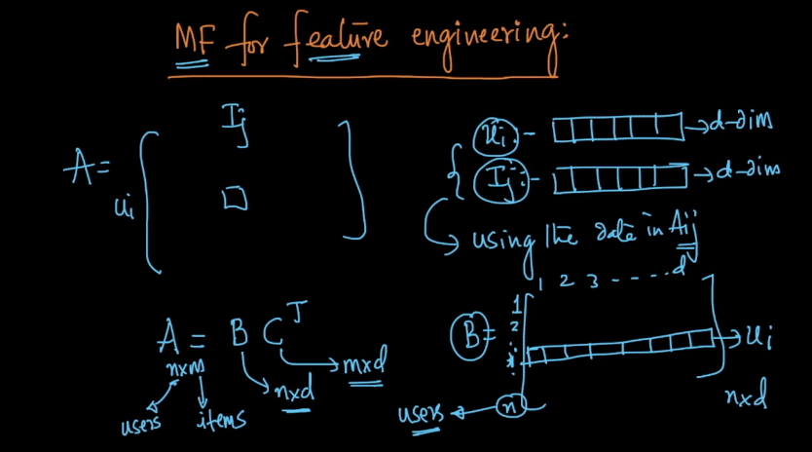

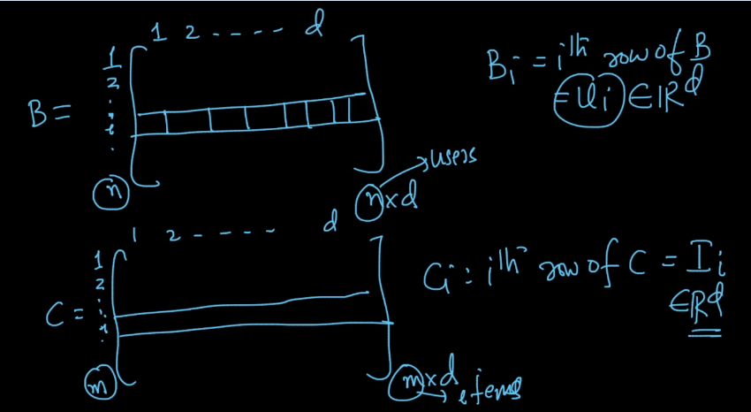

So as we see here B and C can be of any dimension only thing is it should be d>0 and d<=m,n

Otherwise we can take any value of d for B and C therefore we can do feature engineering and we can take any dimension as we want

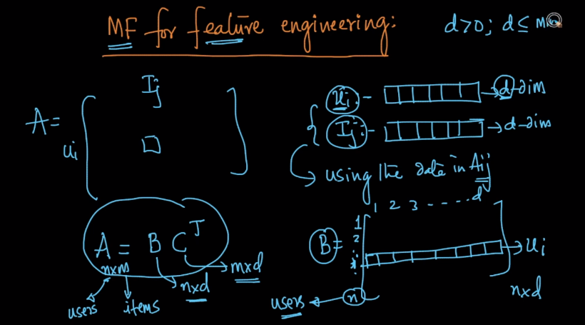

In the d-dim. Representation we arrived at using MF :

If ui and uj are very similar in their ratings of products/items then distance between ui and uj is small

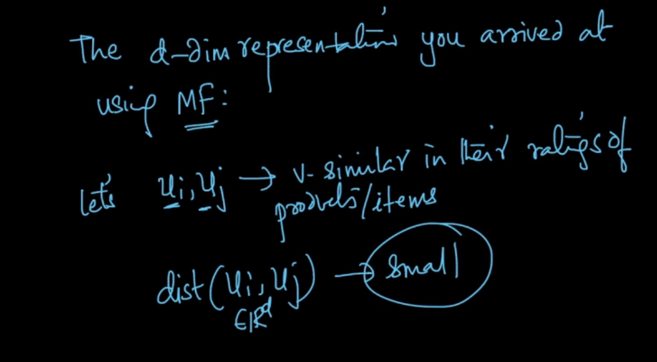

Similarly for Item

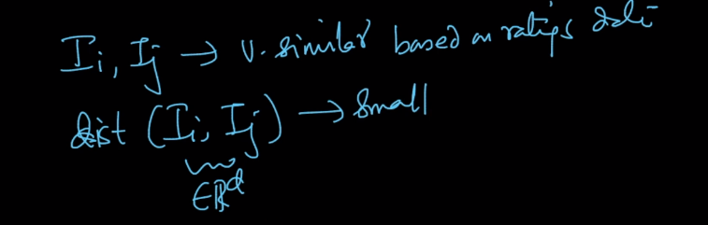

Therefor MF can be use for feature engineering in word-vectors

And eigen-faces : feature engineering for face-images

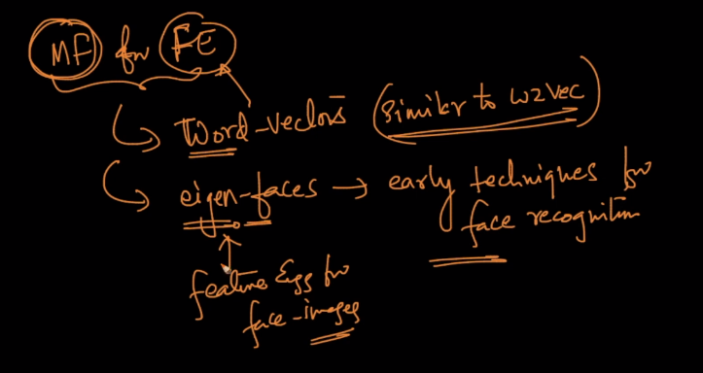

Comments :

